**Santander Holdings USA**



**Enterprise Risk appetite Framework**

**Table of Contents**

1. Introduction - 3 -

1.1 Background - 3 -

1.2 Scope - 3 -

1.3 Purpose of the Enterprise Risk Appetite Framework - 3 -

1.4 Document Ownership and Maintenance - 3 -

2. Components of a Risk Appetite Framework - 4 -

2.1 Risk Appetite - 4 -

2.2 Definition of a Risk Appetite Framework - 4 -

2.3 The Risk Appetite Statement (“RAS”) - 5 -

2.4 Consistency in Risk Appetite - 5 -

2.5 Common Risk Methodology Across SHUSA - 5 -

3. Risk Appetite Principles - 6 -

4. The Risk Appetite Statement - 8 -

4.1 Principles for defining RAS quantitative metrics and qualitative statements - 8 -

4.2 Allocating the RAS - 8 -

4.3 Remuneration – linking Risk Appetite to business performance - 8 -

5. SHUSA Risk Appetite Roles and Responsibilities - 9 -

5.1 SHUSA ownership structure - 9 -

5.2 The SHUSA Board of Directors - 9 -

5.3 The Chief Executive Officer, Chief Risk Officer and Chief Financial Officer - 9 -

5.4 Key Risk Management Committees - 10 -

5.4.1 The SHUSA Risk Committee (“RC”) - 10 -

5.4.2 The SHUSA Enterprise Risk Management Committee (“ERMC”) - 10 -

5.5 Three Lines of Defense - 11 -

5.6 Line 1 Units - SHUSA, its Subsidiaries and their Business Lines & Business Support Units - 11 -

5.7 Line 2 – Risk Management Units - 12 -

5.8 Line 3 – Internal Audit and Credit Risk Review Functions - 13 -

6. The Risk Appetite Statement Process - 13 -

6.1 Setting the Risk Appetite Statement - 14 -

6.2 Testing the business plan against the Risk Appetite Statement - 15 -

6.3 Monitoring performance against Risk Appetite - 16 -

6.4 Escalating limit breaches and establishing action plans - 16 -

6.5 Risk Appetite Policies and Procedures - 16 -

7. Regulatory References - 17 -

8. Document History and Version Control - 17 -

8.1 Ownership and Authorship - 17 -

8.2 Sign-Off - 17 -

1. Introduction
   1. Background

The identification, assessment, control, monitoring, testing and reporting of risks across all risk types, together with the clear articulation and communication of risk appetite, provide the foundation for the SHUSA risk management program. This program is based upon successful implementation of a forward looking risk management discipline to strengthen SHUSA’s resilience to shocks, whether originating internally or externally, thereby providing a stable environment for business activities.

Risk Appetite, as a cornerstone of the enterprise wide risk management program, is an effective tool for SHUSA´s Board to ensure that Enterprise-wide risk is aligned to the risk types and risk levels it is willing to accept in the pursuit of its business objectives, and that any changes identified in the risk profile of SHUSA or its Subsidiaries will be effectively reflected in the expression of risk appetite.

* 1. Scope

The Santander Holdings USA, Inc. (“SHUSA”) Risk Appetite Framework (“RAF”) applies to SHUSA and its subsidiaries.

* 1. Purpose of the Enterprise Risk Appetite Framework

The SHUSA Board of Directors (“Board”) has approved an Enterprise Risk Management (“ERM”) Framework that sets the principles of SHUSA’s oversight of risks arising from its business activities and operations and governs its risk management activities.

This RAF must be read in conjunction with the SHUSA ERM Framework as its purpose is to comply with the ERM program in relation to the definition, setting, monitoring, control and governance of Risk Appetite.

* 1. Document Ownership and Maintenance

The SHUSA Chief Risk Officer (“CRO”) is the owner of and is responsible for the development and maintenance of the RAF. The SHUSA Director of Risk Appetite has primary responsibility for ensuring it is implemented and embedded on a day-to-day basis.

The RAF is approved by SHUSA Enterprise Risk Management Committee (“ERMC”).

The RAF must be reviewed at least annually and updated as necessary in the event of material changes relating to the way risk appetite needs to be defined, managed and controlled. Material changes will be approved by the ERMC. Non-material changes, such as changes to committee names or clarifications to the RAF contents will be approved by the Director of Risk Appetite.

1. Components of a Risk Appetite Framework
   1. Risk Appetite

Risk Appetite defines the types and, where appropriate, level of risk that SHUSA is willing and able to accept in pursuit of its strategic objectives. The elements of Risk Appetite are:

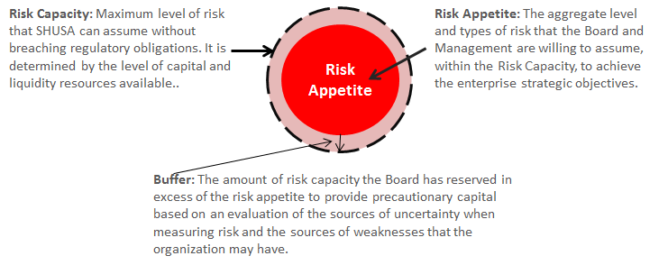

* 1. Risk Appetite Management

A strong risk appetite framework is articulated through the following five pillars:

* This RAF that defines the principles, roles and responsibilities, controls, monitoring, reporting and governance of the risk appetite setting process;
* The Board-approved Risk Appetite Statement (“RAS”), that includes qualitative statements and quantitative metrics that cover the risks SHUSA is willing to accept;
* Risk policies that define the criteria that must be met in order to accept certain categories of risks;
* Lower level limits, thresholds and triggers developed by SHUSA and its Subsidiaries, in order to disaggregate the risk appetite metrics and adapt them to the types of business, their legal structure and their activities;
* The risk appetite reporting that must be available to the Board and senior management, including the analysis of SHUSA’s risk profile used to inform decisions on risk appetite.
  1. Consistency in Risk Appetite

The Risk Appetite of the subsidiaries should be consistent with the Risk Appetite of SHUSA. The Risk Appetite is cascaded down to SHUSA’s Subsidiaries and their Business Lines and documented in their entity specific RAS.

Each subsidiary shall send its risk appetite proposal, before it is approved, to SHUSA RC and the SHUSA Board for it to be evaluated and discussed with the purpose of ensuring it fits in the risk appetite of SHUSA. SHUSA may propose a more restrictive criterion in appetite to ensure that it fits in with the SHUSA appetite as a whole.

* 1. Common Risk Methodology Across SHUSA

The SHUSA Risk Appetite function establishes common guidelines for SHUSA and its subsidiaries in order to enable risk appetite metrics aggregation and the adequate treatment of concentration and correlation of risks. Each subsidiary’s risk appetite shall be structured in accordance with the aforementioned guidelines, including additional requirements as needed due to regulatory requirements or specific features of the business.

1. Risk Appetite Principles

The following are the SHUSA Risk Appetite principles, applicable to SHUSA and its Subsidiaries when reviewing Risk Appetite and setting the Risk Appetite Statement and Limits:

* **Comprehensive coverage of risks –** Risk Appetite metrics should provide comprehensive coverage of all key risks identified by SHUSA as relevant to the pursuit of its business objectives.
* **Cascading effect of the risk appetite** – SHUSA risk appetite will be established based on a thorough analysis of the risk profiles of the subsidiaries and their business lines. The result is a consolidated risk profile at the SHUSA level. SHUSA risk appetite will be designed to manage the consolidated risk profile and risk taking activities of the subsidiaries to align with the SHUSA risk appetite. The SHUSA risk appetite will then be cascaded to the subsidiaries and documented in their entity specific RAS’s.
* **Board approval and management engagement** – The RAS is reviewed by the SHUSA Risk Committee and is approved by the Board. It is driven by both top-down Board leadership and bottom-up involvement of management at all levels, and embedded and understood across SHUSA and its Subsidiaries. Each subsidiary RAS is submitted to the SHUSA RC and Board for review prior to approval.
* **Integration into the ERM program** – Risk Appetite is an integral component of the SHUSA ERM program defined in the SHUSA ERM Framework. Risk Appetite is consistent with, and incorporated into, the capital, strategic and resolution plans as part of the enterprise wide risk management program.
* **Connection to the strategic and business plans** – The SHUSA RAS limits determine the boundaries within which the SHUSA strategic and business plans are set. The risk appetite process promotes robust discussions on necessary risk taking activities and serves as a basis upon which the Board of SHUSA, the business managers, the risk management and the internal audit functions can effectively debate business recommendations and decisions.
* **Forward looking** – The risk appetite process is forward looking and it establishes expectations around SHUSA’s consolidated risk profile in a variety of circumstances based on stress tests and / or scenario analysis.
* **Dynamic and ongoing** – The risk appetite process must be dynamic and responsive to changes in the business environment or the business activities of SHUSA or its Subsidiaries. The assessment of the risk profile of SHUSA should be ongoing and iterative.
* **Stress-testing the business plans** – A key element of business planning is testing the enterprise’s business plans against plausible but stressed scenarios. The outputs of this testing exercise should be used to assess if a current business plan could breach the Board’s defined risk appetite. This stress-testing allows the Board and senior management to understand the risks embedded in the business strategy, including any new or increasing risks identified through the planning process, and SHUSA’s resilience to withstand plausible stress scenarios. The outcomes of the business plan stress testing may result in a modification of the plans to keep the risk profile within the risk appetite limits or may require a review and adjustment to the RAS to accommodate a new business strategy.

1. The Risk Appetite Statement
   1. Principles for defining RAS quantitative metrics and qualitative statements

The following principles must be followed when defining metrics, in order to ensure that they effectively articulate risk appetite and support the management of risks across the organization:

* The set of metrics should reflect the risk exposure of SHUSA across all key risks, where possible;
* Metrics should be **SMART**; they should be **S**traight forward, **M**easurable, and **A**ctionable. All metrics should be **R**isk-based and **T**ied to earnings, liquidity, capital, leverage, exposure concentration or asset quality;
* Metrics should be limited in number, allowing brief and concise communication;
* Each risk type should be accompanied by a clear statement, approved by the Board, to determine the maximum level of risk that SHUSA is willing to accept, thereby providing a reference point for self-imposed risk constraint;
* The SHUSA RAS will be articulated around a set of core metrics that will be applied at SHUSA and its Subsidiaries to facilitate an aggregated view of all risks on a consolidated basis;
* Subsidiaries may establish other metrics relevant to their activities;
* Metrics should enable allocation of risk appetite to risk types and be suitable for further cascading to Business Line and Line of Business as required;
* Metrics and limits should provide clear senior management accountability for risk at Business Line level; and
* Metrics should consider all related regulation, assuring compliance with it and, in case of regulatory changes, they should be reviewed and adapted in a timely manner.

In addition to quantitative limits and metrics, the RAS will include qualitative statements that express the risk appetite for risks that do not lend themselves to expression through a metric. These statements will be targeted at promoting a safe and sound risk culture, ethical conduct and business practices.

* 1. Remuneration – linking Risk Appetite to business performance

Risk Appetite needs to be included within employees’ objective setting and performance management to ensure a balanced approach to risk taking at all levels of SHUSA and its Subsidiaries.

1. SHUSA Risk Appetite Roles and Responsibilities
   1. The SHUSA Board of Directors

The Board is responsible for reviewing and approving the SHUSA RAS and will ensure that it is developed in consultation with Banco Santander, S.A.

The Board will ensure that the RAS remains aligned to SHUSA’s strategic plan and, to discharge this responsibility, the Board will receive regular and comprehensive information from the senior management of SHUSA.

In the event of a trigger or breach of a RAS limit, the Board will be required to approve action plans if the breach meets one or both of the following criteria:

* The CRO, with the sign-off of the RC, determines that the trigger or breach is severe enough to warrant Board approval;
* The proposed remediation plan involves either adjustment of a RAS metric calibration or a temporary acceptance of a breach of a trigger or limit.

The Board is also responsible for reviewing the subsidiary RAS’s and providing feedback prior to them being submitted through the governance of the subsidiary for approval.

* 1. The SHUSA Risk Committee (“RC”) of the Board of Directors

The RC is responsible for reviewing and recommending the SHUSA RAS to the Board for approval.

With the expectation set out below the RC will review and approve the action plans submitted by the RAS metric owners and the CRO in the event of a trigger or breach of a RAS limit. The RC will ensure that the Board is notified of its actions. [1]

The RC is also responsible for reviewing the subsidiary RAS’s and providing feedback prior to them being submitted through the governance of the subsidiary for approval.

* 1. The SHUSA Enterprise Risk Management Committee (“ERMC”)

The ERMC is chaired by the SHUSA CRO. It is responsible for the oversight and monitoring of all risk-taking and risk management activities across SHUSA, including oversight of compliance matters. With regards to risk appetite, the ERMC’s responsibilities include:

* Review on an ongoing basis, and approve no less frequently than annually, the SHUSA Risk Appetite Framework ensuring that it remains appropriate in light of regulatory requirements, SHUSA’s financial and competitive position and strategic goals, and Banco Santander, S.A.’s Risk Appetite;
* Review on an ongoing basis, and recommend to the Board for approval no less frequently than annually, the SHUSA Risk Appetite Statement ensuring that is appropriate in light of general economic conditions, regulatory requirements, and SHUSA’S financial and competitive position and strategic goals, including considering the scenarios utilize in stress testing exercises;
* Initiate changes to the RAS in response to changing conditions to ensure they remain applicable to SHUSA’s strategy, applicable risks, and current and planned activities;
* Monitor and oversee SHUSA’s risk profile generally, including but not limited to, enforcement of and compliance with the RAS;
* On an ongoing basis, but no less than monthly, it shall aggregate and escalate information to the RC that is sufficient to understand the performance of SHUSA and its Subsidiaries against the RAS, in such a manner and with such frequency as to enable the RC to discharge its obligations with regards to Risk Appetite;
* Review and escalate to the Board any breaches in the RAS limits and provide recommendation on the remediation plans;
* Review and oversee the remediation of any issues identified by, or escalated to, the ERMC with respect to SHUSA’s compliance with risk appetite limits.
  1. The Chief Executive Officer, Chief Risk Officer and Chief Financial Officer

Risk Appetite management requires active participation of the Chief Executive Officer (“CEO”), the Chief Risk Officer (“CRO”) and the Chief Financial Officer (“CFO”). Each of these roles is responsible for the following to take place as it relates to the RAS:

* Establish and propose a risk appetite which is appropriate for SHUSA and is consistent with the short and long term strategy, capital plan, liquidity and business plans, and is within the risk capacity as well as supervisory expectations
* Monitor the cascading of Risk Appetite to business lines and units which are consistent with SHUSA’s Board approved risk appetite
* Escalate RAS breaches to the Board, recommending remedial actions and ensuring that they are executed as approved by the Board

The details of the processes can be found in the SHUSA Risk Appetite metrics monitoring, reporting, breach escalation and remediation procedure.

* 1. Three Lines of Defense

SHUSA and its subsidiaries organize their roles and responsibilities for risk management into a “three lines of defense” model, with separately defined and segregated responsibilities consistent with applicable regulations and guidance as outlined in the ERM Framework.

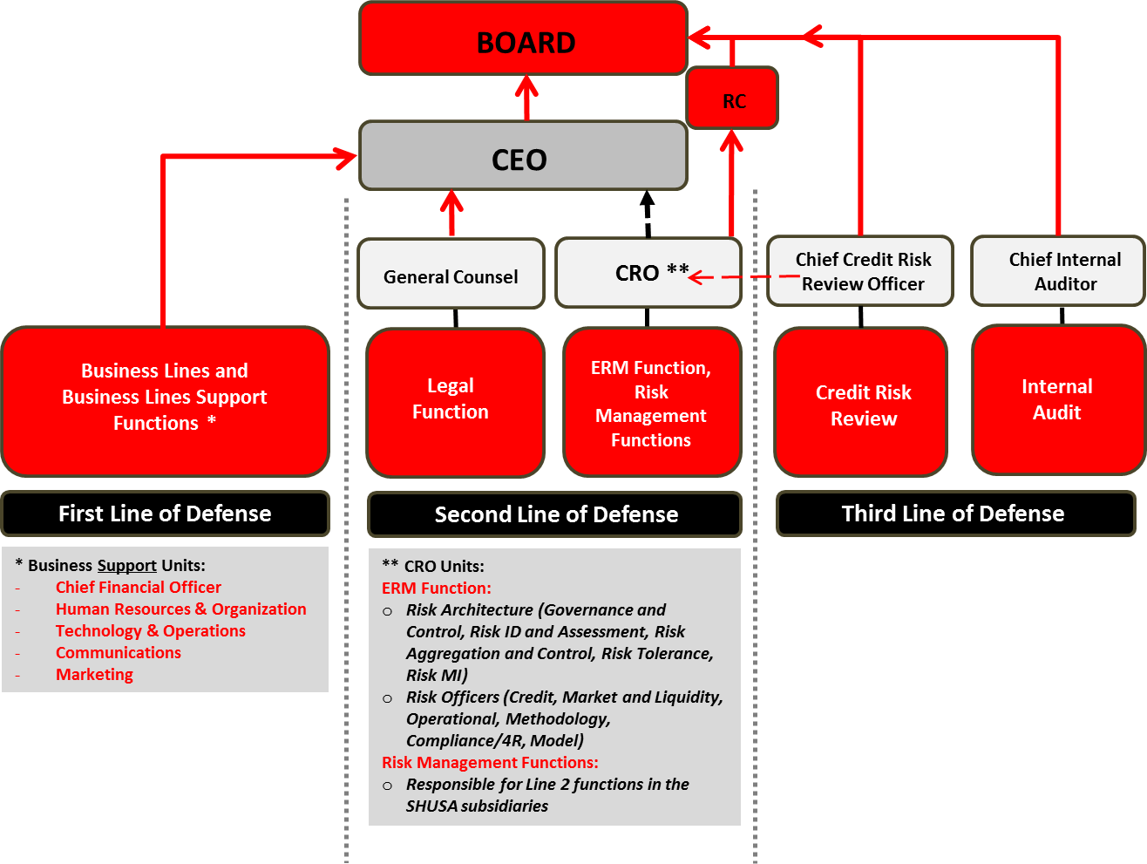

* 1. First Line of Defense – Front Line Units (SHUSA, its Subsidiaries and their Business Lines & Business Support Units)

The roles and responsibilities of the front line as they relate to Risk Appetite are as follows:

* Develop a business plan that includes sufficient risk profile metrics as to enable the assessment of its risk appetite requirements;
* Propose any required changes to the RAS in order to align risk appetite to business plans and strategic initiatives;
* Ensure that all new business initiatives, including but not limited to new products, are tested against, and adhere to, the approved Risk Appetite. Propose new Risk Appetite limits if required;
* Propose the allocation of RAS limits into Subsidiaries and Business Lines limits, where necessary;
* Develop the necessary procedures to embed risk appetite limits into the day-to-day management of the business activities;
* Manage risks in accordance to the Risk Appetite, acting in a timely manner to ensure effective management, and where necessary, mitigation of risk exposures, in particular those that have the potential to exceed the approved risk appetite and/or risk limits;
* Escalate with immediate effect any breaches of risk appetite limits or thresholds, in line with the Risk Appetite breach escalation procedure; propose management actions to address those breaches;
  1. Second Line of Defense – Independent Risk Management

Reporting to the SHUSA CRO, SHUSA Enterprise Risk Management and the SHUSA risk management officers along with the respective teams within the SHUSA Subsidiaries have the following responsibilities with regards to the RAS:

* Ensure that all Risk Appetite proposals are aligned to the risk profile, size and complexity of SHUSA;
* Review and challenge the business plan versus the RAS at each respective Subsidiary; identify any impacts of the proposed business plan on the RAS;
* Ensure that the RAS proposal is aligned to the guidelines set out by Banco Santander S.A. and that it is approved through the proper corporate governance;
* Assist the CRO to discharge his responsibilities by providing independent advice on the Risk Appetite limits proposed by the Subsidiaries and the Business Lines, ensuring that all material risks are covered by the RAS;
* Define and propose risk policies aligned to the approved risk appetite;
* Assist the Business Lines in the allocation and communication of lower level risk limits, thresholds and key risk indicators; and propose these limits for approval at the appropriate governance level;
* Ensure the Risk Appetite impact of a new product or product design changes are suitably understood, and incorporated into agreed product design. Provide formal sign-off including conditions as required.
* Conduct independent verification of compliance with the risk appetite limits;
* Monitor and aggregate reporting on limits for the respective risk areas;
* Escalate limit breaches and ensure remediation plans are appropriate and effective;
* Provide risk performance input for compensation programs.
  1. Third Line of Defense – Internal Audit

The third line of defense provides independent assessment on all aspects of the RAF and the RAS. Their responsibilities include, but are not limited to:

* Review the RAS providing independent validation of the completeness of the RAS principles and its alignment to regulatory expectations
* Review the effectiveness of the implementation of the RAF and the RAS, including linkage to strategic and business planning, compensation, and decision-making processes;
* Identify whether breaches in risk limits are being appropriately identified, escalated and reported, and on the effectiveness of remediation actions;

1. The Risk Appetite Statement Process

The process for setting the Risk Appetite Statement can be divided into three stages:

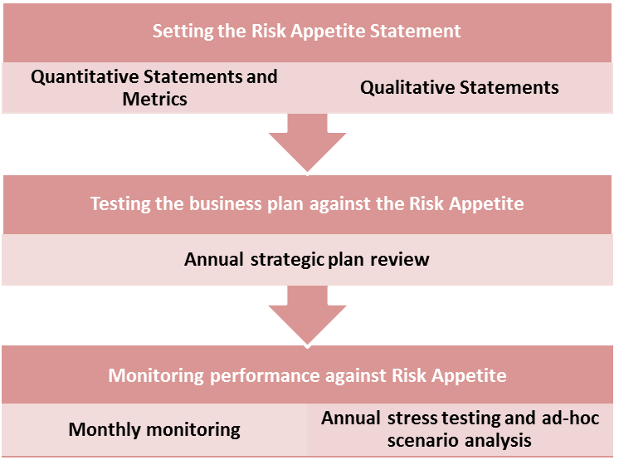

* 1. Setting the Risk Appetite Statement

Setting the RAS includes defining the qualitative statements and quantitative metrics, and their allocation by Subsidiary and Business Line where applicable and align with the Banco Santander S.A.. It is at a minimum an annual process that evaluates the metrics and the levels in order to confirm that they continue to operate as designed. Evaluation confirms that the RAS remains a comprehensive expression of the material risks faced by SHUSA and its Subsidiaries and reflect the level of risk that the Board seeks to take.

This process must also be followed on an ad-hoc basis when the composition and the structure of SHUSA or its Subsidiaries or their businesses change in a significant manner (e.g., when a Subsidiary is bought or sold, or there is a material change in the strategic plan, or a material deviation in the macro-economic outlook).

* 1. 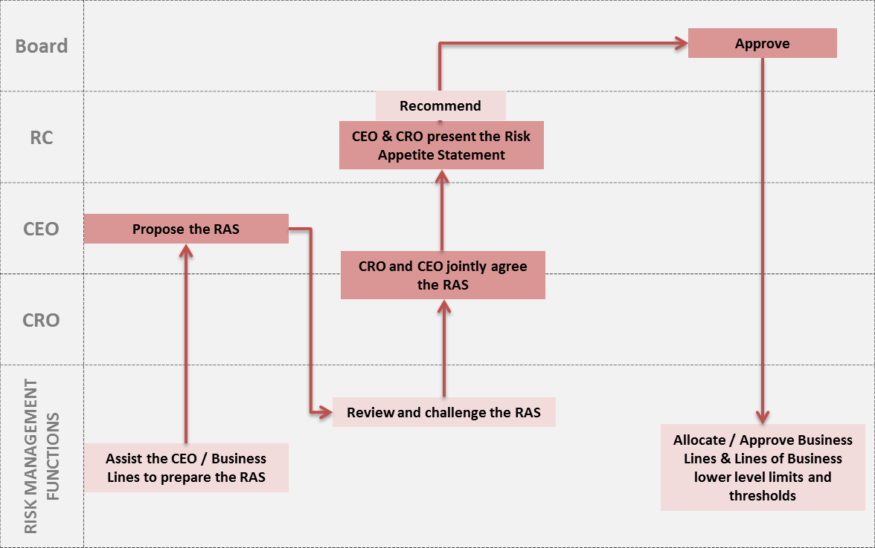
  2. Testing the business plan against the Risk Appetite Statement

This is an annual process where the new business plan and its potential performance under stress scenarios are assessed against the stated and approved Risk Appetite. If there is any inconsistency between the proposed business plan and the Risk Appetite, then two options are available:

* Revisit the business plan so it is consistent with the approved Risk Appetite;
* Review the Risk Appetite to accommodate the business plan needs.

Key to this process is the integration of Risk Appetite into the Strategic Plan, the Capital plan and the Recovery and Resolution Plan, Talent and Compensation plans, and any other relevant enterprise-wide risk management programs.

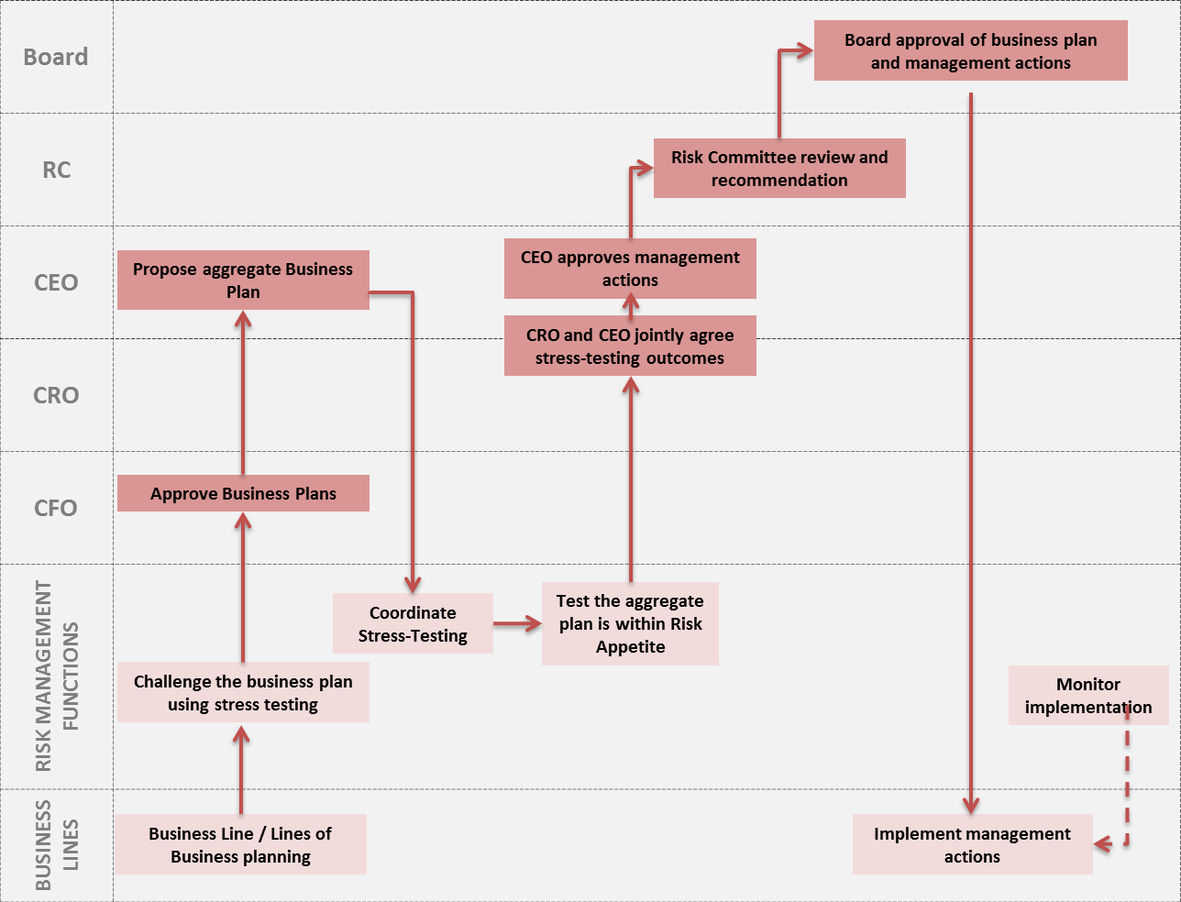

* 1. Monitoring performance against Risk Appetite

A Monthly monitoring and control process is undertaken by Independent Risk Management that compares the actual values of the risk appetite metrics against the metrics.

This process will detect current or potential breaches of the risk appetite limits, In the case of a breach, the business line owner of the metric will be required to propose remedial actions for review by the Risk Management areas and escalation to senior management and governance body.

* 1. Escalating limit breaches and establishing action plans

In the context of Risk Appetite, a limit breach is when the actual measure performance of a Risk Appetite metric exceeds the Board-approved Appetite limit. Early warning indicators should be put in place to prevent and highlight movements and/or trends in the metrics that may indicate a potential future breach, thus enabling early management actions to avoid breaches.

* 1. Risk Appetite Policies and Procedures

SHUSA has drafted the “SHUSA Risk Appetite metrics monitoring, reporting, breach escalation and remediation procedure” (“Breach Procedure”) to govern the process by which Risk Appetite Breaches are managed. The Breach Procedure is owned by the CRO and approved at least annually by the ERMC in accordance with the guidance therein.

1. Regulatory References

Financial Stability Board – Principles for an effective Risk Appetite Framework – November 2013

Federal Reserve System – Framework for Risk-Focused Supervision of Large Complex Institutions – sr9724a1 – August 8, 1997

Federal Reserve System – Consolidated Supervision Framework for Large Financial Institutions – sr12-17 – December 17, 2012

1. Document History and Version Control
   1. Ownership and Authorship

|  |  |  |  |  |
| --- | --- | --- | --- | --- |
| **Version** | **Date** | **Author** | **Owner** | **Change** |
| 1.0 | May 2015 | Director of Risk Appetite | CRO | Initial SHUSA Enterprise Risk Appetite Framework |
| 1.1 | October 2015 | Director of Risk Appetite | CRO | Minor updates to align SHUSA and subsidiaries |
|  |  |  |  |  |

* 1. Sign-Off

|  |  |  |
| --- | --- | --- |
| **Approving Body** | **Governance Committee Approval or Endorsement** | **Final Approval Date** |
| Enterprise Risk Management Committee | N/A | September 2015 |
| Director of Risk Appetite | N/A | November 19, 2015 |
|  |  |  |

1. Refer to the SHUSA Risk Appetite metrics monitoring, reporting, breach escalation and remediation procedure